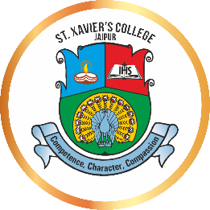
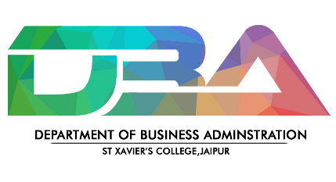
INYOUTH
Date: 21st October, 2023

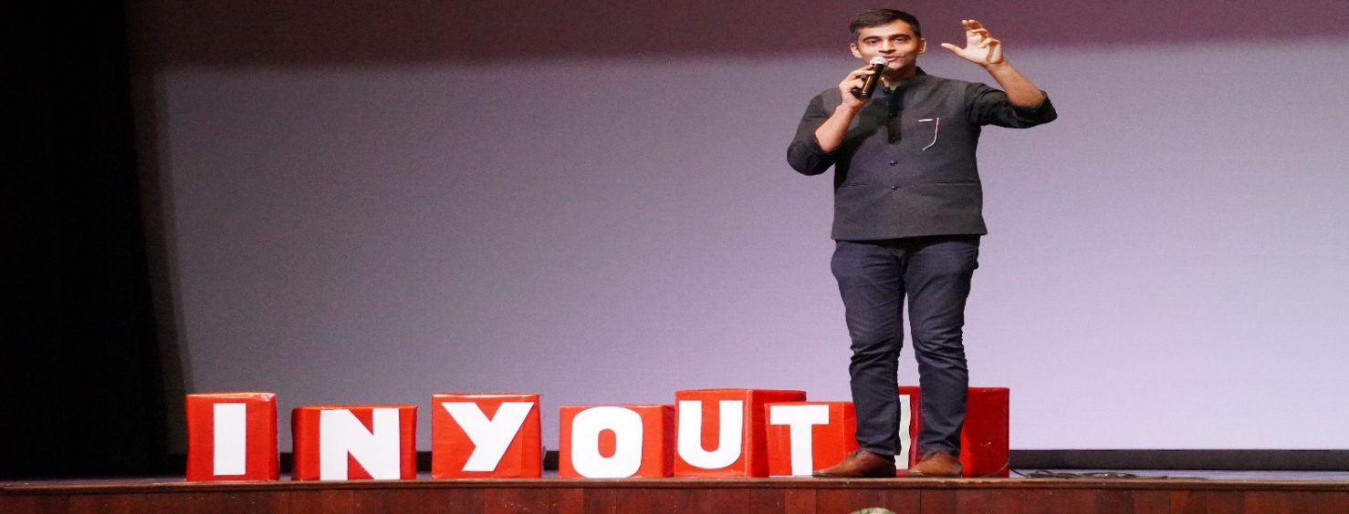
Department of Business Administration in collaboration with E- Cell of St. Xavier’s College, Jaipur, held an event entitled “INYOUTH.” The members of the Entrepreneurship Cell, under the guidance of Head of Department Dr. Leena Sharma (Faculty coordinator) and faculty coordinator Ms. Anjali Pareek organized the event with the theme “Infinite Perspectives: Shaping Future” aim to invite personalities from different walks of life and young minds to brace themselves for a dose of inspiration like never before which were conveyed by the inspiring guest speakers. It featured a diverse and accomplished set of speakers from various fields, including Mr Divas Gupta, Ms. Saloni Khanna, Mr. Vikram Agnihotri, Mr. Amit Lodha and Mr. Adarsh Suyal. The event was followed by the guest speakers who shared personal experiences, challenges, and success stories that left attendees inspired and motivated to pursue their academic and professional aspirations. Each word of wisdom and advice were highly appreciated by the students of all the guest speakers, and they gave feedback on their valuable contribution. Attendees had the opportunity to engage in thought-provoking talks and panel discussions on a wide range of topics with professionals, fostering valuable academic and career connections.
