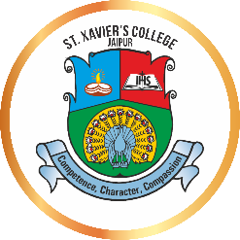
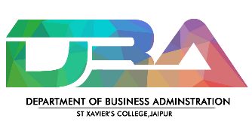
Expert Lecture Report on
Campus to Corporate Readiness

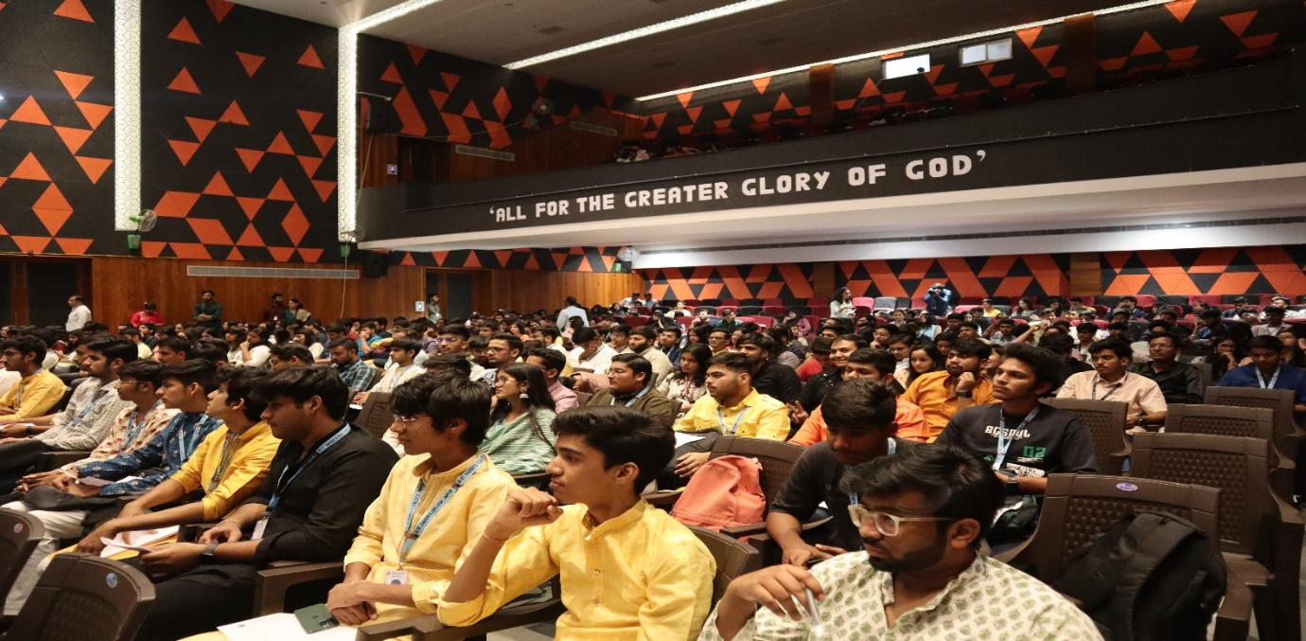
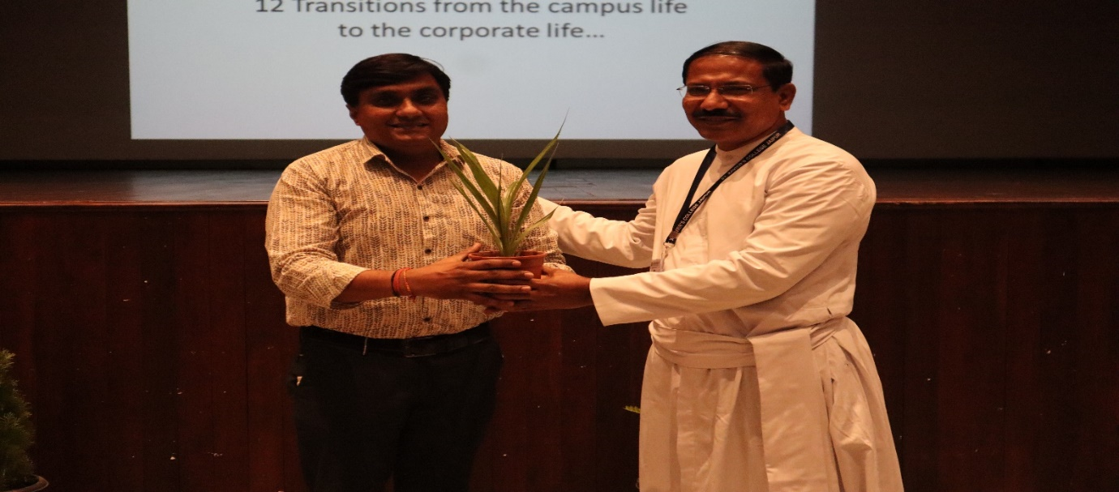
The event titled “Campus to Corporate Readiness” held on October 18th, transcended the typical gathering experience; it marked a day of profound transformation. Mr. Bhati, taking the stage not merely as a speaker but as a guide, shared his life experiences and wisdom, prompting the audience to reflect on their own paths. The subsequent discussion and question session fostered a lively exchange. This event transcended mere knowledge acquisition; it was about forging connections, nurturing minds, and rejoicing in the promising futures that lie ahead.
