EVENT MANAGEMENT

Course Code: BADM/AO/EM-23
Course Duration: 30 Hours

Brief Description- The Add-on Course on Event Management offers students a comprehensive understanding of the principles, practices, and strategies involved in planning, organizing, and executing successful events. Through a combination of theoretical knowledge and practical applications, students will develop the essential skills and competencies necessary to thrive in the dynamic field of event management.
• It is a 30-hour course (2-3 classes in a week) according to the schedule.
• Examination: - Assessment will be based on an exam in which students have to get at least 50% marks.
• Attendance: - At least 75% attendance in the course is compulsory to sit in the exam of this course.
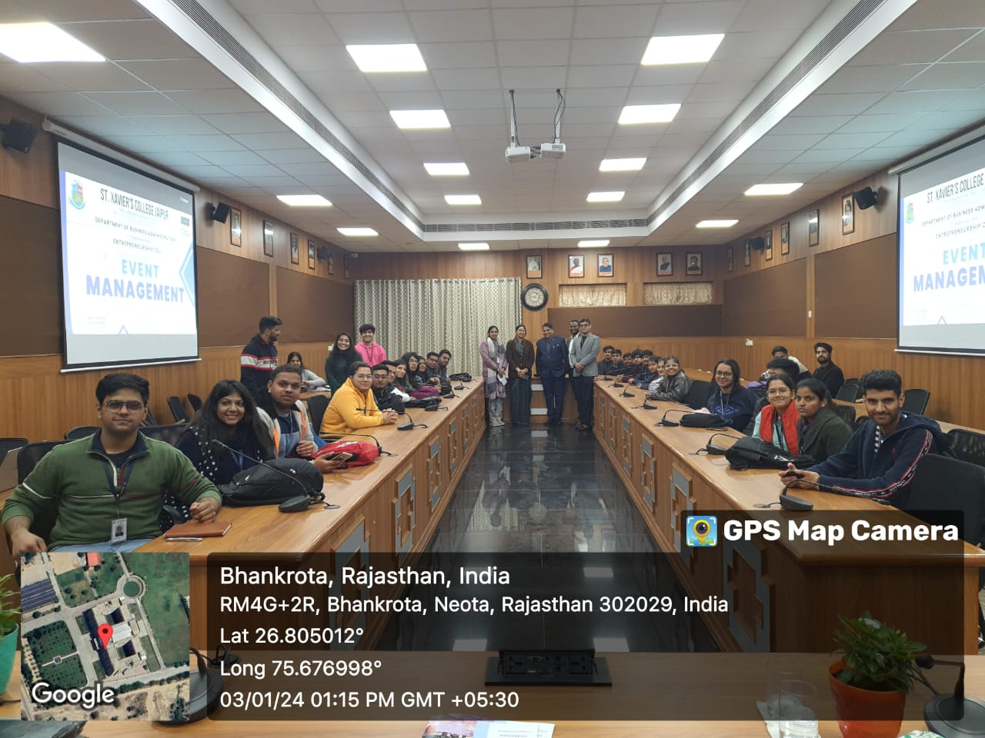
• After completion of the Certificate Course, students will get a certificate for the same.
