St. Xavier’s College Jaipur
Department/Cell/Club/Committee Annual Report 2023-24

- About the Department/Cell/Club/Committee (in brief – max 100 words):
- Member Details:
- Head of Department/Coordinator
- Members

- Objective: (Key objectives of organizing events/programs/ work performed in the last academic year in points only)

- Result Analysis for the last three academic years as per the template given below (applicable for Departments only):
AY | Class | Students Admitted | Students Appeared in Exam | Total Students Pass | Total Students Failed | Pass Percent
2020-21 | FY
 | SY
 | TY
 | Prev
 | Final
2021-22 | FY
 | SY
 | TY
 | Prev
 | Final
2022-23 | FY
 | SY
 | TY
 | Prev
 | Final

- Achievements of the students/faculty/unit in the academic year (if any):

- Details of the Activities organized/ Work Performed (Not more than 500 -700 words)
- Name of event/ Work performed
- Name of event/ Work performed
- Name of event/ Work performed
- Name of event/ Work performed
- Name of event/ Work performed.
Note: Please mention the following points in your activity/ work performed description:
- Date of event/ work performed
- Name and description of event/ work performed
- Details of resource person, if any
- Target audience
- Learning outcome
- Any suggestion for improvement based on the feedback or otherwise

- Posters and Pictures Supporting the Activities/ Work performed (max four normal and two-three geo-tag photos as thumbnail) – can be avoided by those units where there is no photographic evidence of work performed

Example 1:
Sanitizing Machines Installed at Various Places in Campus (Library, Staff Room 1 and 2, Principal Office, Entrance, Vice-Principal Office, Computer Lab)

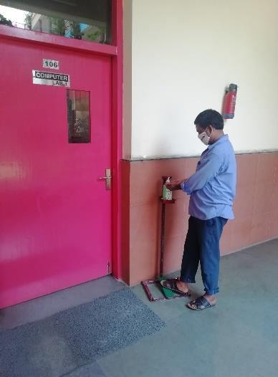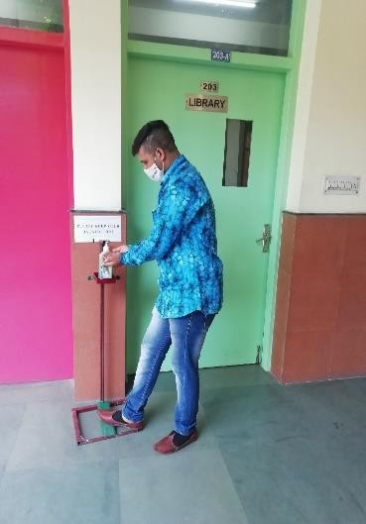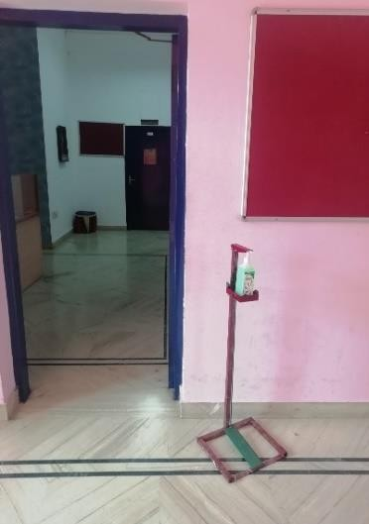

Example 2:

Webinar on “Beware but don’t be scared: COVID-19: Precautions we can take”

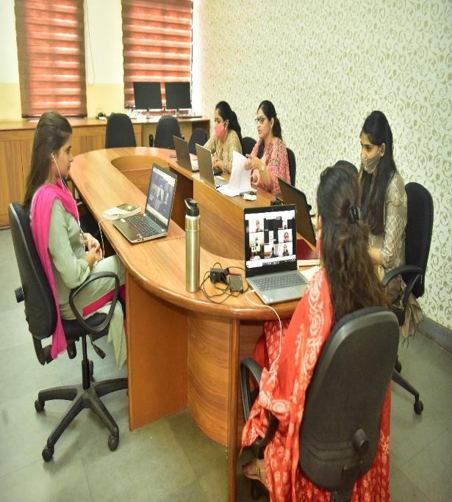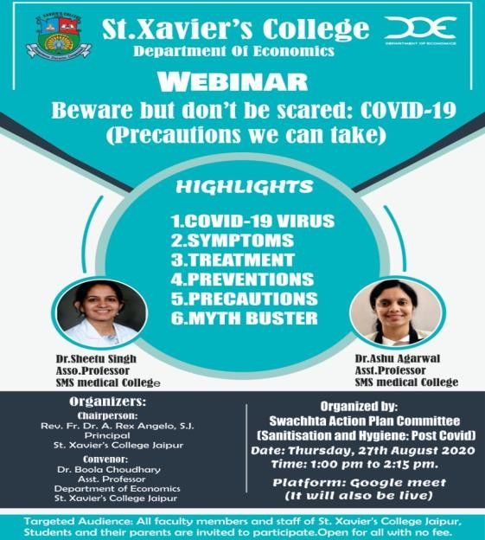

Example 3: Blood Donation Drive
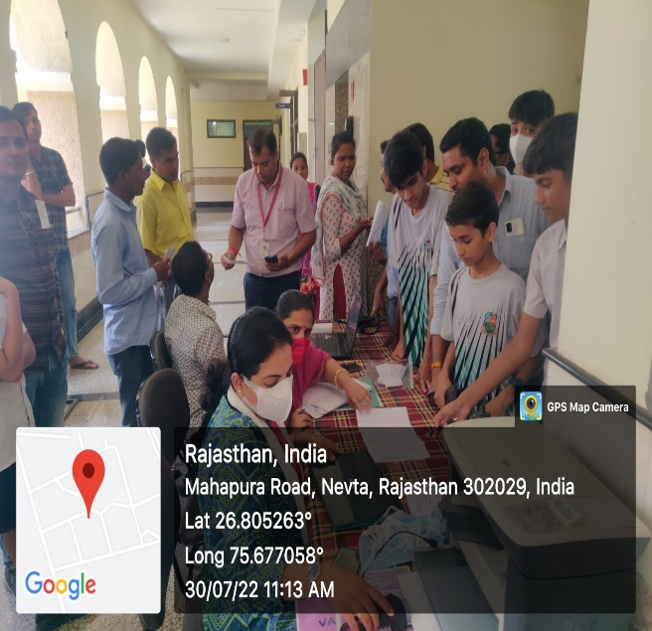 | 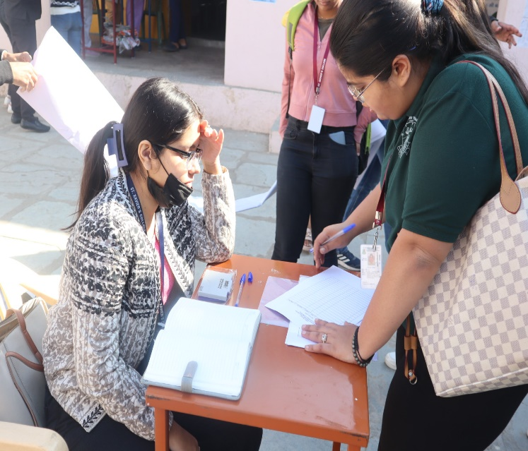

- Media Coverage of Events: (wherever applicable)
Example 1: Deeksharambh – Student Induction Programme for session 2023-24
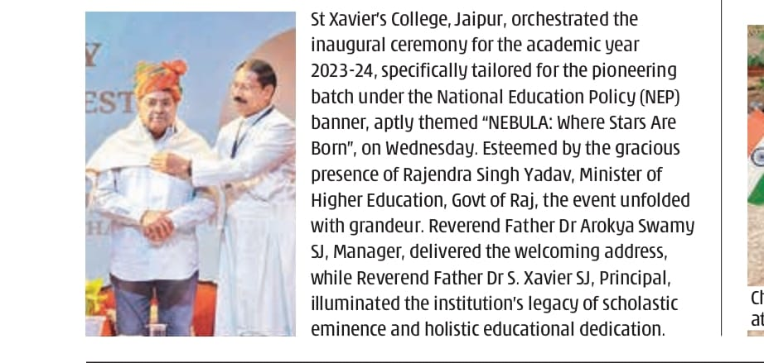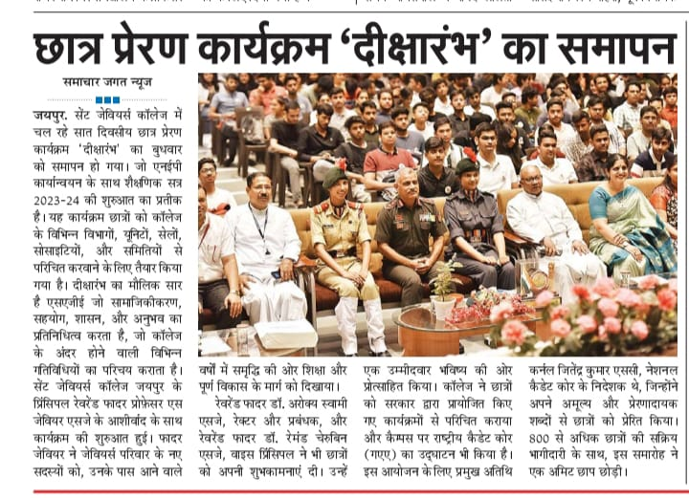
- Future Plans for the next academic year (briefly mention in points)
Report Submitted by Head of Department/ Coordinator of Cell/Club/Committee:

