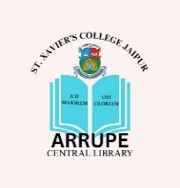
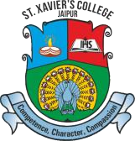
St. Xavier’s College Jaipur
Affiliated to the University of Rajasthan, Jaipur

Accredited with A Grade by NAAC (First Cycle, 2025)
An ISO 14001:2015 Certified Institution

ARRUPE CENTRAL LIBRARY

Book Requisition Form
Following books are required in to the library: -

S.No. | Title | Author | Publisher | Cost | No. of Copies
Recommended by:-
Name of Faculty
Department
Signature
Signature HOD Date
- Use another sheet if required.

